RAM(Random Access Memory) is a part of computer’s Main Memory which is directly accessible by CPU. RAM is used to Read and Write data into it which is accessed by CPU randomly. RAM is volatile in nature, it means if the power goes off, the stored information is lost. RAM is used to store the data that is currently processed by the CPU. Most of the programs and data that are modifiable are stored in RAM.

Integrated RAM chips are available in two form:

1. SRAM(Static RAM)
2. DRAM(Dynamic RAM)

The block diagram of RAM chip is given below.

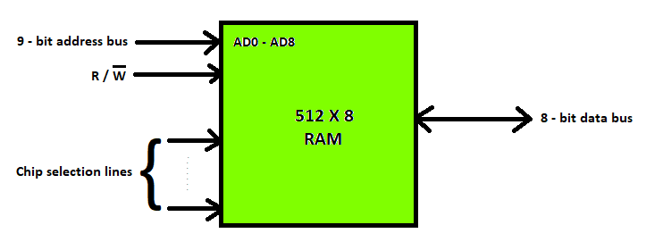

**SRAM**

**Types of DRAM**

There are mainly 5 types of DRAM:

1. **Asynchronous DRAM (ADRAM):** The DRAM described above is the asynchronous type DRAM. The timing of the memory device is controlled asynchronously. A specialized memory controller circuit generates the necessary control signals to control the timing. The CPU must take into account the delay in the response of the memory.
2. **Synchronous DRAM (SDRAM):** These RAM chips’ access speed is directly synchronized with the CPU’s clock. For this, the memory chips remain ready for operation when the CPU expects them to be ready. These memories operate at the CPU-memory bus without imposing wait states. SDRAM is commercially available as modules incorporating multiple SDRAM chips and forming the required capacity for the modules.
3. **Double-Data-Rate SDRAM (DDR SDRAM):** This faster version of SDRAM performs its operations on both edges of the clock signal; whereas a standard SDRAM performs its operations on the rising edge of the clock signal. Since they transfer data on both edges of the clock, the data transfer rate is doubled. To access the data at high rate, the memory cells are organized into two groups. Each group is accessed separately.
4. **Rambus DRAM (RDRAM):** The RDRAM provides a very high data transfer rate over a narrow CPU-memory bus. It uses various speedup mechanisms, like synchronous memory interface, caching inside the DRAM chips and very fast signal timing. The Rambus data bus width is 8 or 9 bits.
5. **Cache DRAM (CDRAM):** This memory is a special type DRAM memory with an on-chip cache memory (SRAM) that acts as a high-speed buffer for the main DRAM.

**Difference between SRAM and DRAM**

Below table lists some of the differences between SRAM and DRAM:  
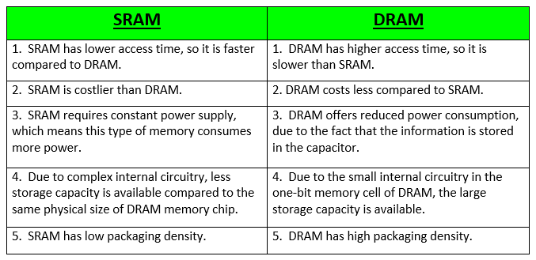

**Performance Comparison of RAM Types**

|  |  |  |  |  |  |  |  |
| --- | --- | --- | --- | --- | --- | --- | --- |
| Standard | Time in Market | Internal Rate | Bus Clock(MHZ) | Perfectch | Data rate(MT/s) | Tranfer rate(GB/s) | Voltage |
| SDRAM | 1993 | 100-166 | 100-166 | 1n | 100-166 | 0.8-1.3 | 3.3 |
| DDR | 2000 | 133-200 | 133-200 | 2n | 266-400 | 2.1-3.2 | 2.5/2.6 |
| DDR2 SDRAM | 2003 | 133-200 | 266-400 | 4n | 533-800 | 4.2-6.4 | 1.8 |
| DDR3 | 2007 | 133-200 | 533-800 | 8n | 1066-1600 | 8.5-14.9 | 1.35/1.5 |
| DDR 4 | 2014 | 133-200 | 1066-1600 | 8n | 2133-3200 | 17-21.3 | 1.2 |

**Summary:**

* The full form of RAM is Random Access Memory.
* Two main types of RAM are 1)Static RAM and 2) Dynamic RAM
* Static RAM is the full form of SRAM. In this type of RAM, data is stored using the state of a six transistor memory cell.
* DRAM stands for Dynamic Random Access Memory. It is a type of RAM which allows you to stores each bit of data in a separate capacitor
* FPM DRAM is a full form of Fast Page Mode Dynamic Random Access Memory
* Rambus Dynamic Random Access Memory is an extended form of an RDRAM
* RAM optimized for video adapters is called VRAM.
* EDO DRAM is an abbreviation of Extended Data Output Random Access Memory.
* Flash memory is an electrically erasable and programmable permanent type of memory
* The full form of DDR RAM is Double Data Rate.
* SRAM has lower access time, so it is faster compared to DRAM.
* RAM is utilized in the computer as a scratchpad, buffer, and main memory.